Christmas, 2002

Hi, folks.

It’s been quite a year for Mary, Claire and me, and I’m sure also for you. With the passing of Joe and Virginia, my thoughts turn more often to family these days. How precious that is. In the light of that I vowed that I wouldn’t let the year end without sending a letter I initially wrote months ago, but failed to finish and get out.

So let me tell you about the trip Mary and I took to visit to Colette and Rashleigh Ball in Omaha, last August 1-4.

In addition to visiting my relatives, we also timed our trip to visit Newton, Iowa, to attend a memorial service for Mary’s recently deceased cousin, Lou Thesz. The memorial service was held at the Lou Thesz /Geroge Tragos International Wrestling Hall of Fame, which is named after Lou. Lou was 86 when he died. In the 40s, 50s, and 60s, Lou held more world titles, and held them longer, than any wrestler in history. Of course this was before wrestling became clowning in the era of television. It was a fascinating immersion in another culture to sit with a dozen or more old-time wrestlers emotionally telling stories about their encounters and friendships with Lou in those old times.

But that was a side trip. Our primary trip was to see Colette and Rashleigh, and Sylvia and George (and family) and to very belatedly celebrate Colette’s 91st birthday, which was in April.

Had a great visit. The highlight was a pilgrimage Colette, Sylvia, Mary, and I made to Mom and Colette’s birthplace, Dodge, Nebraska. For the longest time I had it in my head that they grew up in Norfolk – a town that Nebraskans pronounce “Nor fork”. But no, it is Dodge – or even more accurately, a tiny town just outside of Dodge that’s not on most maps today, called Olean (alternately spelled Oleyen).

After a two hour drive NW from Omaha we stopped we stopped for an historic photo. (History keeps being made.)

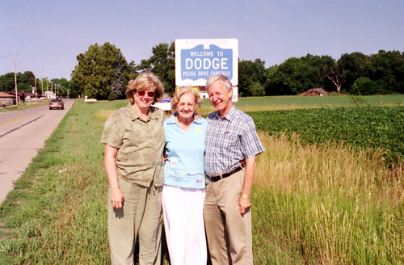
Sylvia Thompson, Colette Ball, Frank Frost ready to check out Dodge, NE.

As we entered the town (which hasn’t lost much of it’s early 20th century character), we came upon, in the middle of a block on the short main street, an old bank building which had been turned into a diner, cutely named “The BankQuit Tearoom.” Seeing the bank triggered a memory for Colette. “My uncle Augy Miller, who married my aunt Clara Schulte, owned a bank in Dodge when I was little, and we used to visit it.” Timing was good for us to have a late-morning snack and soft drink, so we decided to see if this was indeed the same bank building from almost a hundred years ago. But Colette also recollected that August’s bank was on a corner, so she knew this couldn’t be it.

Inside the empty “Tearoom” I went back to the kitchen to roust the proprietor to see if we could get a bite. I told her that Colette had lived on a farm near Dodge when she was a child and had had an uncle who owned a bank. This nice woman, probably about 50, did not have any helpful memory of that time, of course, but after setting us down at a table remembered that she had a copy of the 1986 Dodge Centennial Book, “The History of Dodge, Nebraska,” we could look at. We paged through it.

The history was fascinating. We noted that one section of the book was devoted to families with a history in Dodge. So we turned to that section, looking for Schultes. As I turned one page, Colette exclaimed, “That’s my grandmother!” and jabbed her finger at a picture on the page. Sure enough there on page 244 was Louisa Schulte with two grandchildren Nitha and Roma Miller!

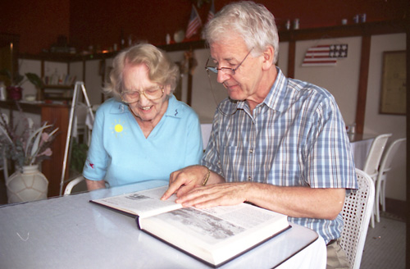 | 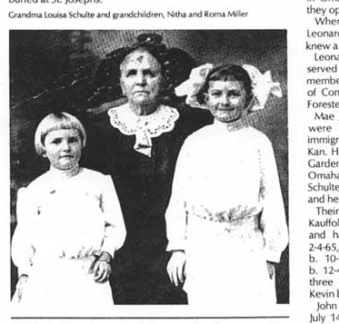
 | Louisa Schulte with grand-children Nitha and Roma Miller

Now we were into it. We pored through the book, asked the owner of the Tearoom if we could buy a copy, and learned there are none to be had. But she suggested I take the book down to the bank on the corner (still active as a bank) and use their copy machine to make copies of pages I wanted. Which I promptly did.

Back with Colette, Sylvia, and Mary we pursued the Schulte names some more. And went on to the Millers. We found the August Miller family, and it turns out that he owned the First National Bank, which became the Dodge State Bank, which further turns out to be the building we were sitting in!

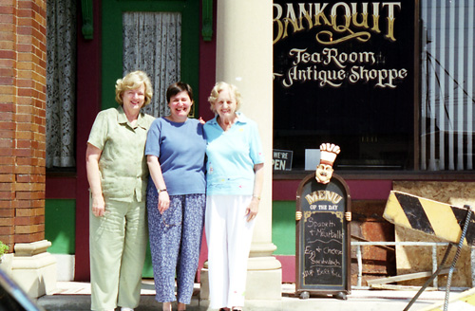

Sylvia Ball, Mary Link Frost, Colette Ball discover the “Schulte Bank” as it is today.

At this point we decided to eat lunch and then go visit the church in Olean where Colette and Carrie, among other Schultes, were baptized.

According to “The History of Dodge,” the original wood frame Sacred Heart of Jesus church from 1877 was rebuilt in brick in 1928, and still stands. (Here’s one for you, Mike and Janet. The first pastor of Sacred Heart of Jesus parish in 1877 was Father John Blaschke.) Since the Schulte farm had been only a couple of miles from the church we also hoped we would be able to find that farm based on Colette’s recognition of the land, and some photos of the farm we had seen at Sylvia’s before driving up to Dodge.

Colette also wanted to visit the church cemetery. She remembered that her mother had lost a couple of children at birth and maybe their tombstones would be there.

The visit to the site of the church gave me a sense of family heritage I’ve never experienced before. In addition to the Church, there was the impressive 2-story brick school (built in 1895) where the four Schulte girls, Ann, Carrie, Alice and Colette, went to school. A picture in the book includes Carrie and Alice Schulte among the 29 students in 1917. Ann was one of three the first 8th grade graduation class in 1916.

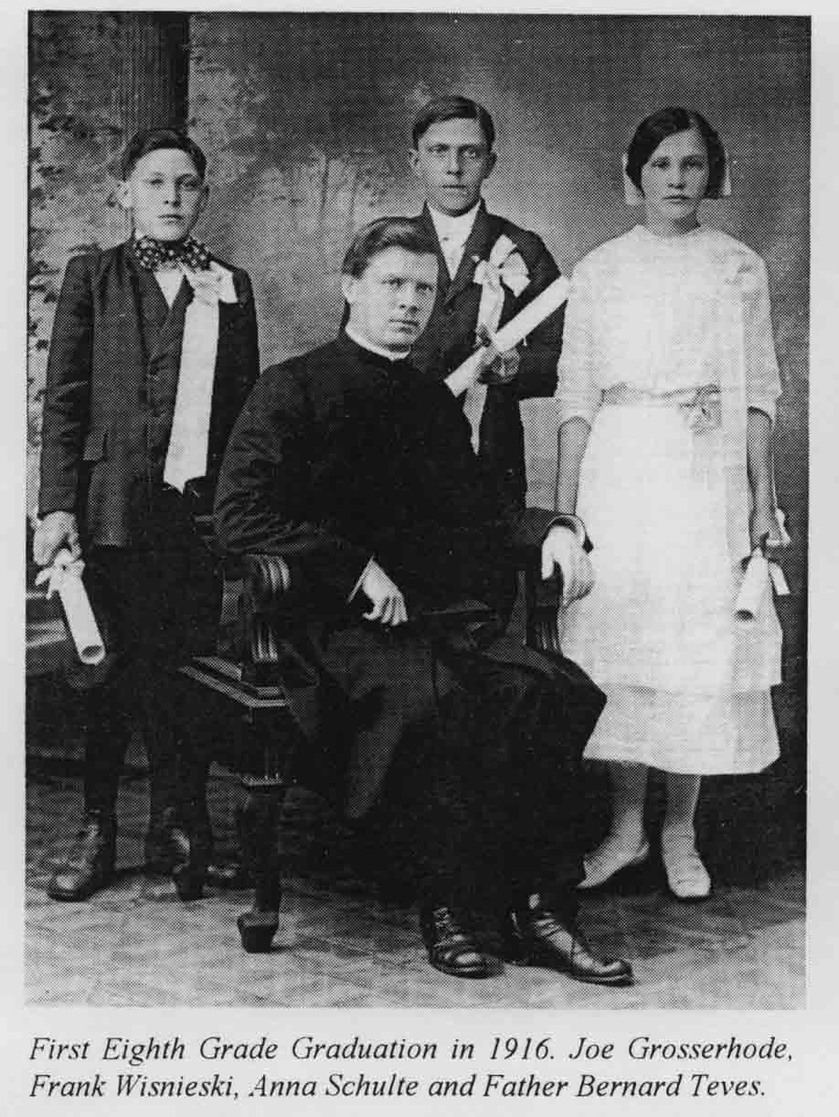

As we walked the small cemetery one of the more notable tombstones was that of Wilhelm Schulte (1829 – 1910), the patriarch of the Schultes who immigrated to Nebraska. Down a few rows we found first one, and then another, and then another small tombstone with a Schulte name. Mary Schulte was born and died on October 22, 1899. That made her Joseph and Elizabeth Schulte’s first child. Not far away was the tombstone of Paul Schulte, b. June 24, 1913, d. June 27, 1913. And near his grave was the third tombstone: John Schulte, born and died July 2, 1915. Paul and John were the last children of Joseph and Elizabeth Schulte.

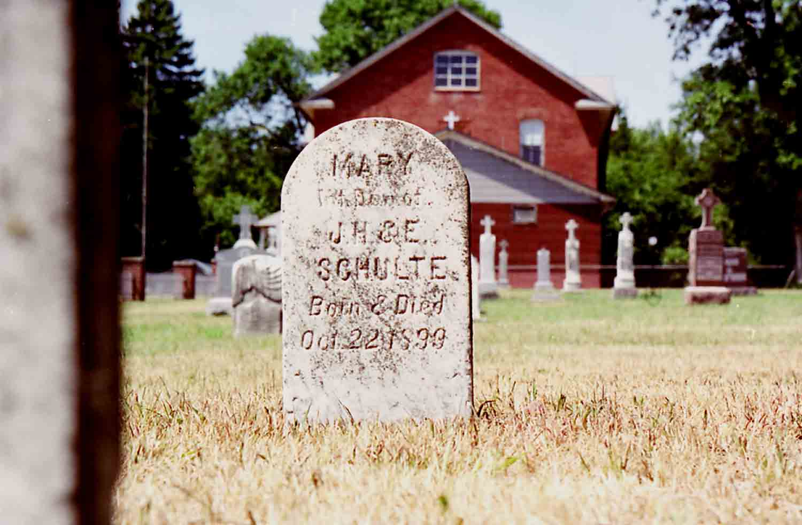 | 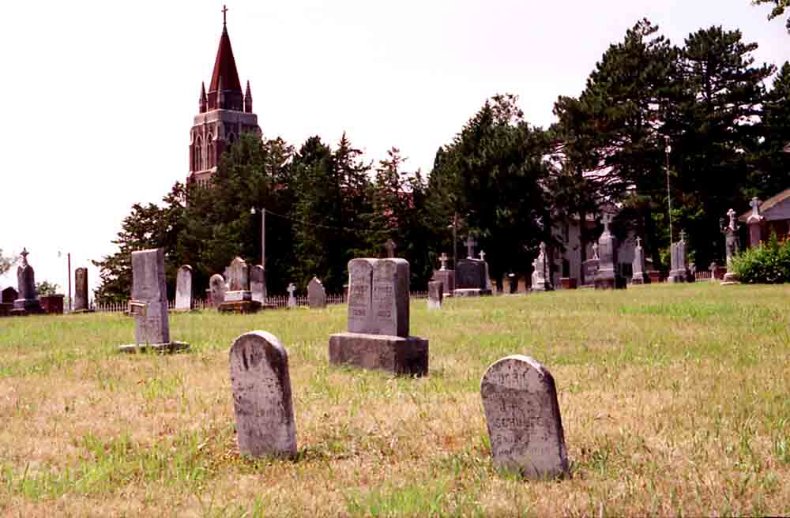
Mary Schulte’s tombstone. In the background is the brick school building  the Schulte sisters attended. | Sacred Heart of Jesus Church and cemetery  in Olean. Tombstones in foreground are those of infants Paul and John Schulte.

From the church we set out to find the Schulte homestead. Colette remembered it being about three miles north of the Church. We took the road that goes past the church for a mile before coming to a T junction, decided to go right, and when we found another road a half mile down we turned north again. As we went along we compared the terrain according to Colette’s memory and the pictures we had seen, allowing for change in the farm buildings. None of the farms matched the pattern, although there was one we could not see because the corn was so tall that we couldn’t see buildings from the road. We went up and down parallel roads before giving up. We then headed back to Dodge and another visit to the BankQuit Tearoom.

There we took another look at “The History of Dodge” to see what else we could find. There was lots of good stuff. But two things of note. One, in the small world department, was a picture of “Joe Stecher, World Champion Wrestler in 1915,” Dodge’s most famous athlete. Joe Stecher figured prominently in the life story of Lou Thesz, who you remember was Mary’s wrestling cousin!

The second thing was the fact that there were two William Schulte families listed in the book. The one was the family of Wilhelm, the patriarch of the Schultes in their initial move to Nebraska, whose grave we had seen at Oleyen. The other was an unexplained William Schulte who still lived in Dodge. Colette told us, “My cousin Bill Schulte lives in Blair, Nebraska. He calls me all the time. I wonder who this William Schulte is.”

I decide to find out. I ask the Tearoom owner if she has a phonebook. She does. There’s a William Schulte in it. She volunteers her phone and even dials the number. I reach a woman who reluctantly calls a reluctant husband in from outdoors. “I’m Frank Frost, I say, the nephew of Colette Schulte…” He interrupts, “Letty! I call her all the time!” So it turns out that cousin Bill doesn’t live in Blair after all, but in Dodge. He invites us over, about six blocks from the BankQuit Tearoom.

We have a good visit with Bill and his wife Evey (Evelyn), see more pictures and talk family. We ask Bill where the Schulte homestead was, and sure enough, it was the one we couldn’t see because the corn was so high!

Bill and Evey also had a history book, this one called, “125 Years of God’s Faithful Love: Sacred Heart of Jesus Catholic Church, Olean, Nebraska, 1874 – 1999. They didn’t have an extra copy and knew they were out of print. But a few weeks later Bill found someone willing to part with one, which we acquired. This book has all the marriage, baptism, first communion, confirmation, and cemetery records of the church. (The records are obviously not terribly reliable since they don’t list Mary, Paul, and John Schulte, but do list a “Schulte, newborn,” who was born and died on July 10, 1916 – someone we didn’t find a tombstone for.) The records drop off fast in the second decade of the 20th century since Dodge got its own parish, St. Joseph’s, in 1912.

By now the afternoon was also gone, and our tentative plan to visit Dodge and then move on to Norfolk, about 45 miles NE, was no longer feasible. So we saved Norfolk and Brunswick for another day.

This was to come back to mind when later in our visit we told Colette and Sylvia about the next Frost reunion planned for 2004. Organizer Stephen Frost had already tentatively set for St. Louis, as an air travel hub in the center of the country. Colette and Sylvia suggested we look at Mahoney State Park just about 20 miles SW of Omaha. We didn’t get there in person, but we looked it up on the web, and we recommend to Stephen that Mahoney would be a great site for a family reunion, a park with living and activity options superior to Algonkian State Park here in Virginia, where we had the 1996 reunion. An additional factor is that if we had the reunion at Mahoney, we would potentially draw a large number of Nebraska Schultes, and also be able to organize pilgrimages to Dodge, Oleyen, Norfolk, and Brunswick, places central to the lives of Karl Frost and Carrie Schulte Frost.

Sylvia and I took a lot of photos of Dodge and Oleyen, and I’ve scanned them into the computer. I also picked up some photos from Sylvia and a sketch of the Yates shaft of the Homestake. I’ll provide a disk of those David P. Frost for the family archive/website. I’ll also provide him copies of the pages I copied from “The History of Dodge.” If anyone else wants these photos or materials for yourself, I’ll be happy to send you your own CD copy. Just let me know.

Have a great 2003!

Love,
Frank

